**Introduction to Statistical Methods**

**(S2-22_AIMLCZC418– Assignment 2)**

**AIML-Section-1**

1. A survey was taken by Automobile company. One of the questions was: “What is your average daily commute distance.” A random sample of 54 responses to this question yielded a mean of daily commuted distance is 10.45 km with S.D. 7.7 km. Find the 90% confidence interval for the mean of distance commute in kilometres.

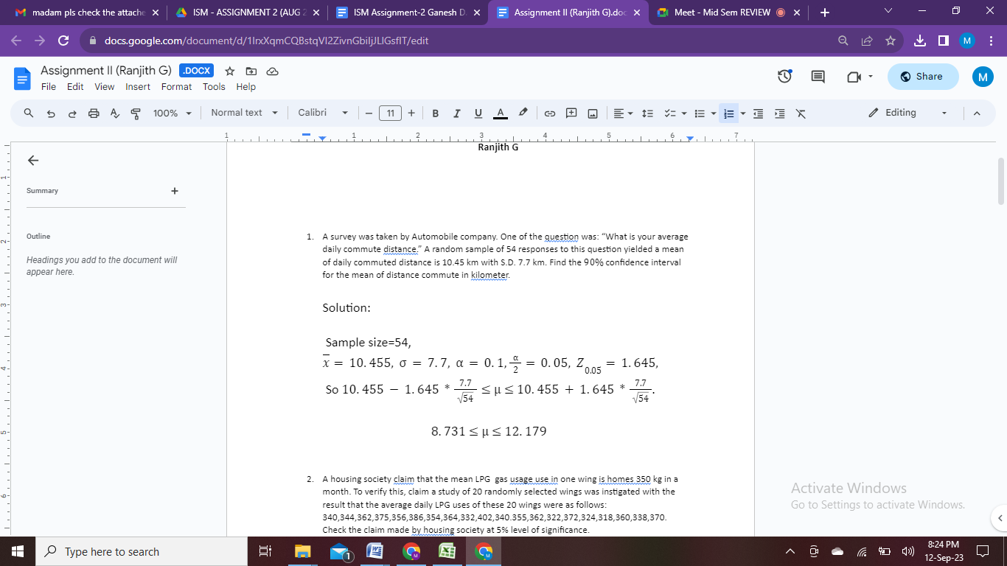

1. A housing society claim that the mean LPG gasusage in one wing in homes is 350 kg in a month. To verify this, claim a study of 20 randomly selected wings was instigated with the result that the average daily LPG uses of these 20 wings were as follows:

340,344,362,375,356,386,354,364,332,402,340.355,362,322,372,324,318,360,338,370.

Check the claim made by housing society at 5% level of significance.

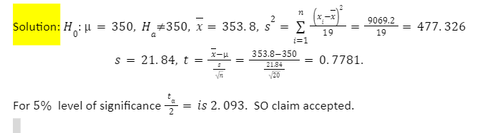

1. A survey was conducted to test whether the mileage of a vehicle varies according to the vehicle type. 4 types of vehicles were considered and following figures for mileage (in km/Litre) were obtained. Consider a significance level of 0.05

|  |  |  |  |  |  |
| --- | --- | --- | --- | --- | --- |
| **Types of Vehical** | Km/Litre | | | | |
| Subcompact | 3 | 5 | 3 | 7 | 6 |
| Compact | 8 | 9 | 15 | 12 | 11 |
| Midsize | 4 | 6 | 3 | 5 | 7 |
| Fullsize | 15 | 10 | 12 | 14 | 10 |

Find

* 1. The sum of squares of treatment (SSB).
  2. The mean square error (MSE).
  3. F statistic value.

Solution:

|  |  |  |  |  |  |  |
| --- | --- | --- | --- | --- | --- | --- |
| **Types of Vehicles** | Km/Litre | | | | | Total (yi) |
| Subcompact | 3 | 5 | 3 | 7 | 6 | 24 |
| Compact | 8 | 9 | 15 | 12 | 11 | 55 |
| Midsize | 4 | 6 | 3 | 5 | 7 | 25 |
| Full size | 15 | 10 | 12 | 14 | 10 | 61 |
| Total( $\sum{yi})$ | | | | | | 165 |

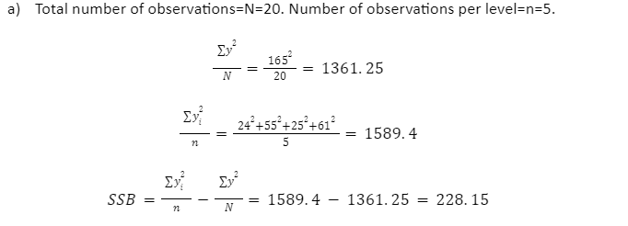

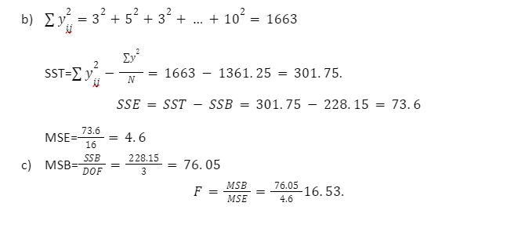

1. Over 72-hours long holiday period a total 300 fatal automobile accidents were recorded on a highway in a state. The data are as follows:

|  |  |  |  |  |  |  |  |
| --- | --- | --- | --- | --- | --- | --- | --- |
| Number of Accidents per hour | 0,1 or 2 | 3 | 4 | 5 | 6 | 7 | 8 or more |
| Number of Hourly period | 14 | 15 | 12 | 12 | 6 | 6 | 7 |

Test the hypothesis that the number of accidents follow Poisson distribution at 5% level of significance.

**Solution:**

|  |  |  |  |  |  |  |  |  |
| --- | --- | --- | --- | --- | --- | --- | --- | --- |
| Number of Accidents per hour | 0,1 or 2 | 3 | 4 | 5 | 6 | 7 | 8 or more |  |
| Observed frequency (Oi) | 14 | 15 | 12 | 12 | 6 | 6 | 7 | Total=72 |

